**Covid Aftermath**

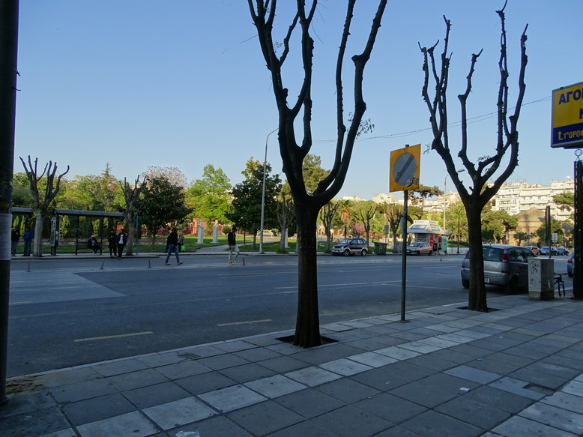

While the most technological countries are occupied with mitigating the consequences of the pandemia, Belarus turned out to be the only country within the EU who did not introduce the lockdown at all.Their governor decided that it will cause people to panic. Also Belarus is known to be a very poor country who seems not able to afford expensive curfew measures. Sweden also hopes that citizens will get herd immunity on themselves. However, gradually lockdown measures are being waived by governments. Small businesses are getting operations restored. Since recent restrictions prevented people from walking near the sea. However, by now access to promenand has already been recovered in Thessaloniki. By mid-June local University will resume onsite classes. Yet all classes are online.

**The investigation**

24 April, 2020 Friday evening. After discussion with a friend via online messenger about the situation with travel. I left home approximately at 18-00. My goal was to investigate how to leave Thessaloniki. My motive was to visit relatives. Continuous seclusion makes me feel exhausted. I wanted to fly to the Ocean to wait until the lockdown ends there. It turned out that my wish was delusional. It wasn’t to happen. The situation with flights got ambiguous because airlines were cancelling their flights all over the world. Moreover, It was not possible to clarify what is actually going on with flights via the Internet. Previously I tried to contact various airlines and ticket sales points. However, it turned out that the average email response from an airline takes a few weeks and doesn’t address the question that I am asking. Points of sales of tickets neither could provide any clear information on travel options.

**Flights**

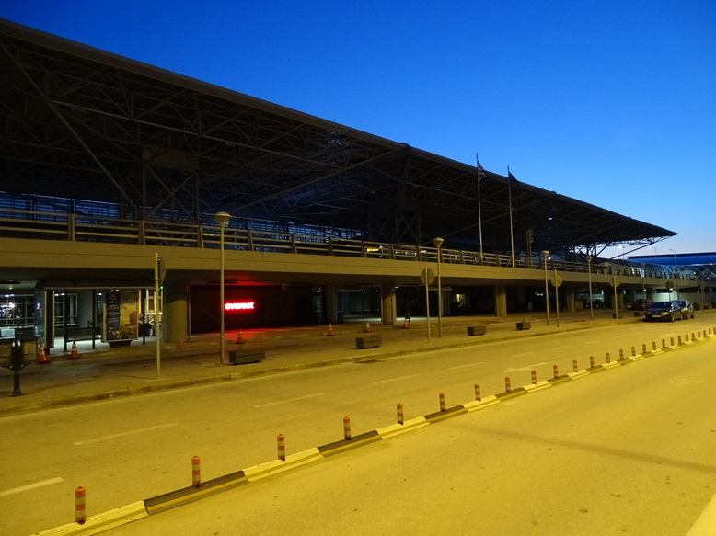

When a friend of mine suggested getting to the nearest airport in person to clarify if I can fly out. I did not have to hesitate as I was bored already of staying in a flat. Perhaps If there were tickets I would fly out to Canarian Islands to continue my remote work and online classes from there. Otherwise, I would find out if I can fly to the nearest relatives or motherland. However, I followed the friend’s advice and found myself in the evening commuting in an empty bus to the local airport with laptop and camera.

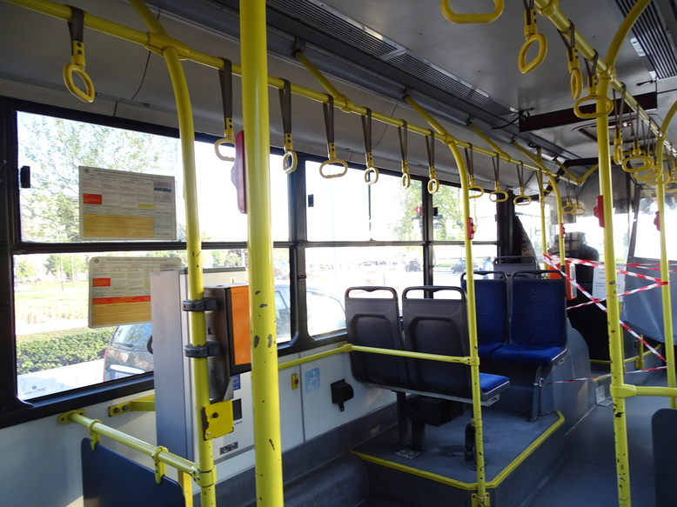

When I arrived at the destination and went out of the bus I understood that I am the only passenger who went out there. The airport building was dark. With almost no illumination. They must be saving energy I thought. After entering the building through wide open doors that were supposed to be automatically closed I found two flight operators. They explained that the only regular flight from Thessaloniki happens once a day in direction to Athens. When I asked them if it is possible to get from Athens to Germany they said that Germany was closed. At this point I decided to check with Google what flights operate. I settled myself with my laptop using the airport wifi connection.

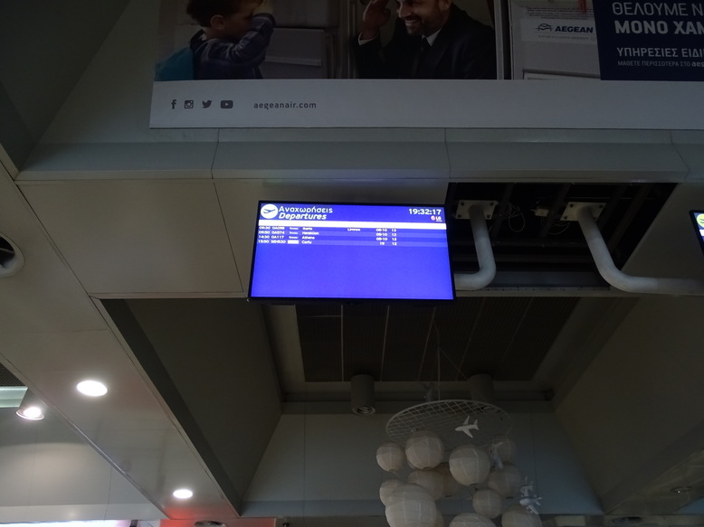

When I tried to hang out with my laptop using the Airport wifi. Approximately after an hour of searching for connecting flights from Athens to anywhere, a group of guards surrounded me asking where I am from and corresponding simple questions. After getting basic responses, they pointed out that I can work with a laptop searching for tickets from home and advised, not to get another time caught by them in the Airport not having a ticket, as otherwise they will have to compose a paper and fine me for violating the regulations that are in force.

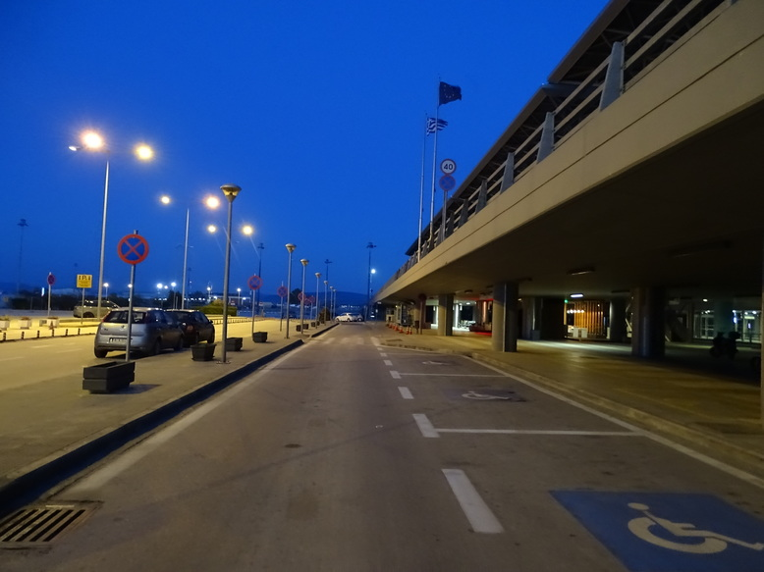

There was also one stranger who got to the bus back to Thessaloniki which I took to get back. However, getting back as the bus was getting people from bus stops they accumulated almost to a pack of dozen.

**Aftermath**

It appears that governments tested a way to mitigate the crisis that emerged due to globalization and industrialization. Nature has had relief which lasted almost a month from humans who were polluting it for ages. The ecological situation improved. Sky over Antarctica recovered ozone holes. What will persist probably, after lockdowns are lifted is total surveillance and control. It appears that people will lose certain freedoms and that may disrupt economics, businesses, and the common people. Many areas will not recover soon. The pandemic has shown that many countries especially in Europe are not ready to face existing challenges and they do not have a mechanism to deal with major threats. Probably it is a disadvantage of democracy. Perhaps certain countries with totalitarian regimes will deal better with issues like the pandemic. However, I believe that within time regulations and governmental systems will improve and that will allow us to address challenges in a coherent way. Moreover, based on the studied mistakes, it will be possible soon to design reactions to similar challenges that will be more effective than before.[source: flights.google.com]